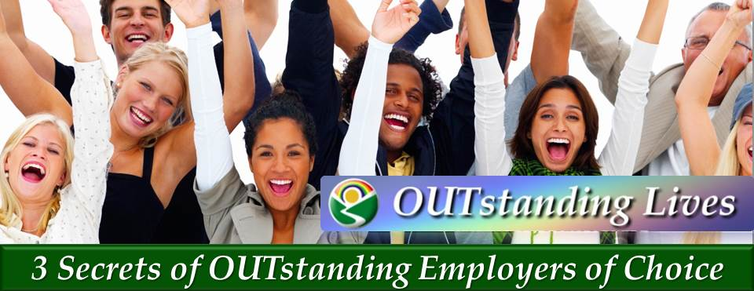

You Can Attract & Inspire Diverse Top Talent

Master the Skills to…

- Create great relationships at home and at work
- Increase loyalty from your LGBT- Friendly colleagues, bosses, clients, prospects, friends and family members
- Enhance teamwork and reduce workplace politics
- Increase your leadership skills & income
- Make a difference build self-esteem in LGBT youth
- Boost your personal power to achieve your goals

Participants will learn:
- Your OUTstanding Vision™: A unique exercise to clarify your dreams &goals
- Your Power of Pride™ : A quick technique to boost your personal power
- The Three Secrets of OUTstanding Employers of Choice™
- The OUTstanding Loyalty & Diversity Quiz Game™
- OUTstanding Real life Case Studies™

