Video Fundraising Secrets to Attract LGBTF Donors
Bet you, too, can attract millions online.* These secrets can help you attract donors more quickly and easily online:
- Powerful title which is Search Engine Optimized for Google & Youtube
- Moving logo for your introduction to build your awareness & credibility
- Inspirational true stories that illustrate your impact & inspire sharing
- Images, humour and/or expressive faces to hold attention
- Music and/or credible vocal variety to gain donor commitment
- Inspiring background
- Offering affiliate video courses or other online products to attract & thank donors, such as the affiliate partnership program at www.outstandinglives.org
- Maximizing traffic through social media and/or crowd source funding sites such as Indiegogo
- Working with an LGBT-owned production company who has attracted millions to support LGBT rights online, such as OUTstanding Lives
- Contacting Sharon Love OUTstanding Lives for a free consultation at Phone: 647-240-2289 , Skype: outstanding.lives or email sharonjlove@facebook.com

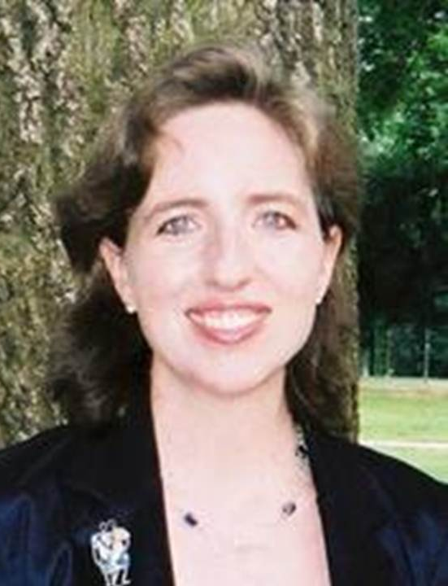
*Sharon Love, M.Ed. (Psychology) is a lesbian who has overcome homelessness and near-mute shyness, inspired over two million people online to support LGBTF equality, and helped her clients attract over ten millions dollars to make a difference. For over twenty years, she has thrilled audiences in French, English and Spanish with presentations and videos. For more information and free secrets, you can visit www.outstandinglives.org. For a free fundraising video consultation, you can phone: 647-240-2289, Skype: outstanding.lives or email sharonjlove@facebook.com.

