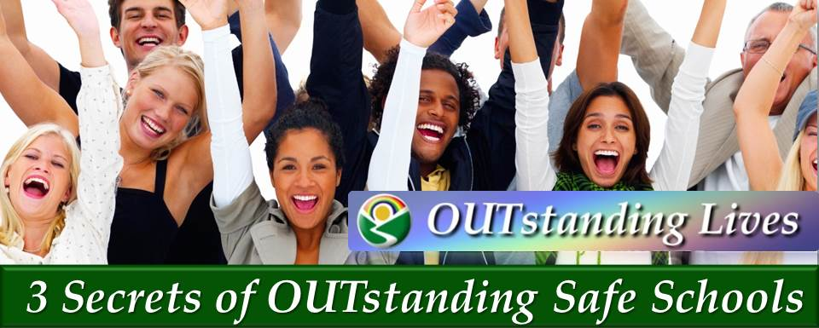
You Can Inspire Self-Esteem in Youth

Master the Skills to…

- Create safe schools
- Inspire self-esteem in teens of all sexual orientations & gender identities
- Create positive relationships at school and at home
- Enhance teamwork and prevent bullying
- Maximize confidence and leadership skills in yourself and others
- Boost your personal power to achieve your goals
- Make a difference and save young lives
You will learn:
- Your OUTstanding Vision™: A unique exercise to clarify your dreams &goals
- Your Power of Pride™ : A quick technique to boost confidence
- The Three Secrets of Inspiring OUTstanding Self-Esteem in Youth ™
- The OUTstanding Safe Schools Diversity Quiz Game™
- OUTstanding Real -Life Case Studies™

